**Cloud Computing**

**UE19CS352**

**6th Semester, Academic Year 2021-22**

Week #: 2 - Introduction to REST APIs with AWS Lambda

and API Gateway

Date: 07/2/2022

|  |  |  |
| --- | --- | --- |
| Name :  SUMUKH RAJU BHAT | SRN :  PES1UG19CS519 | Section :  H |

PES1UG19CS519_1.a. Created lambda function with SRN as name:

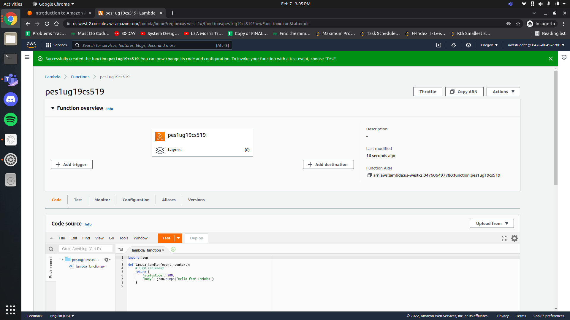

1. b. API Gateway created and unique URL

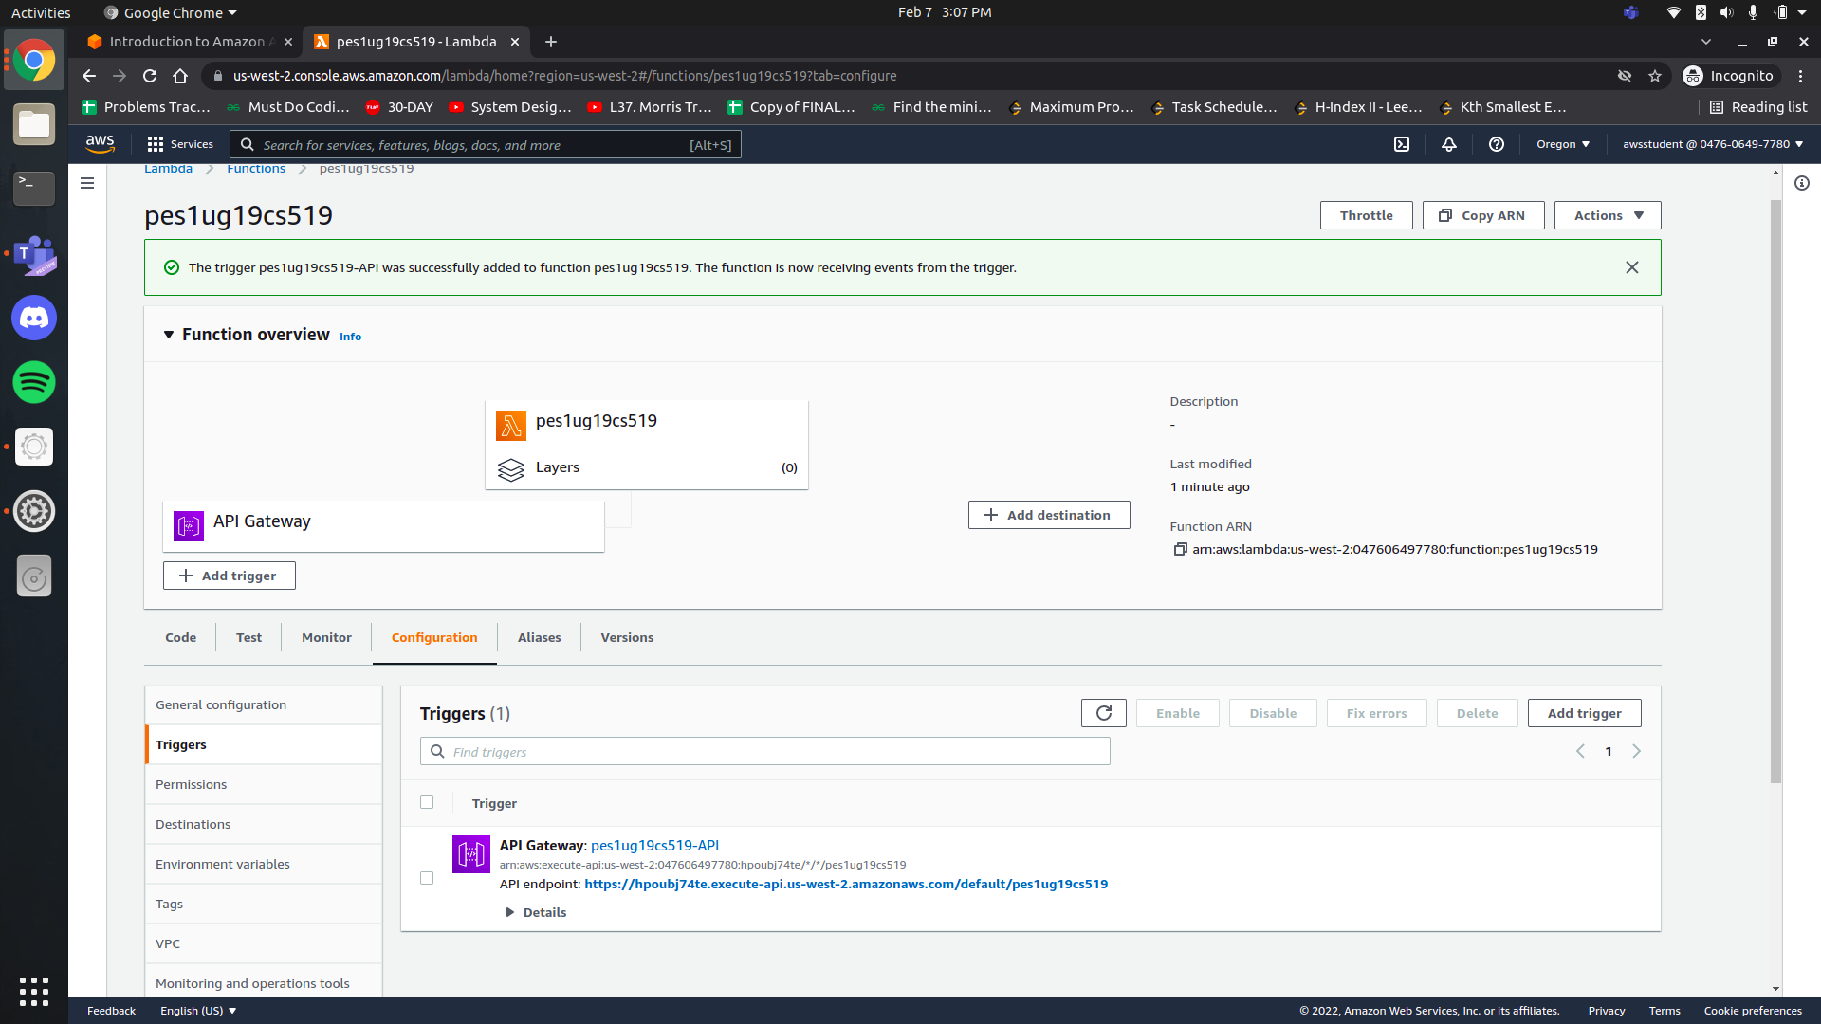

1. c. Lambda Function Code

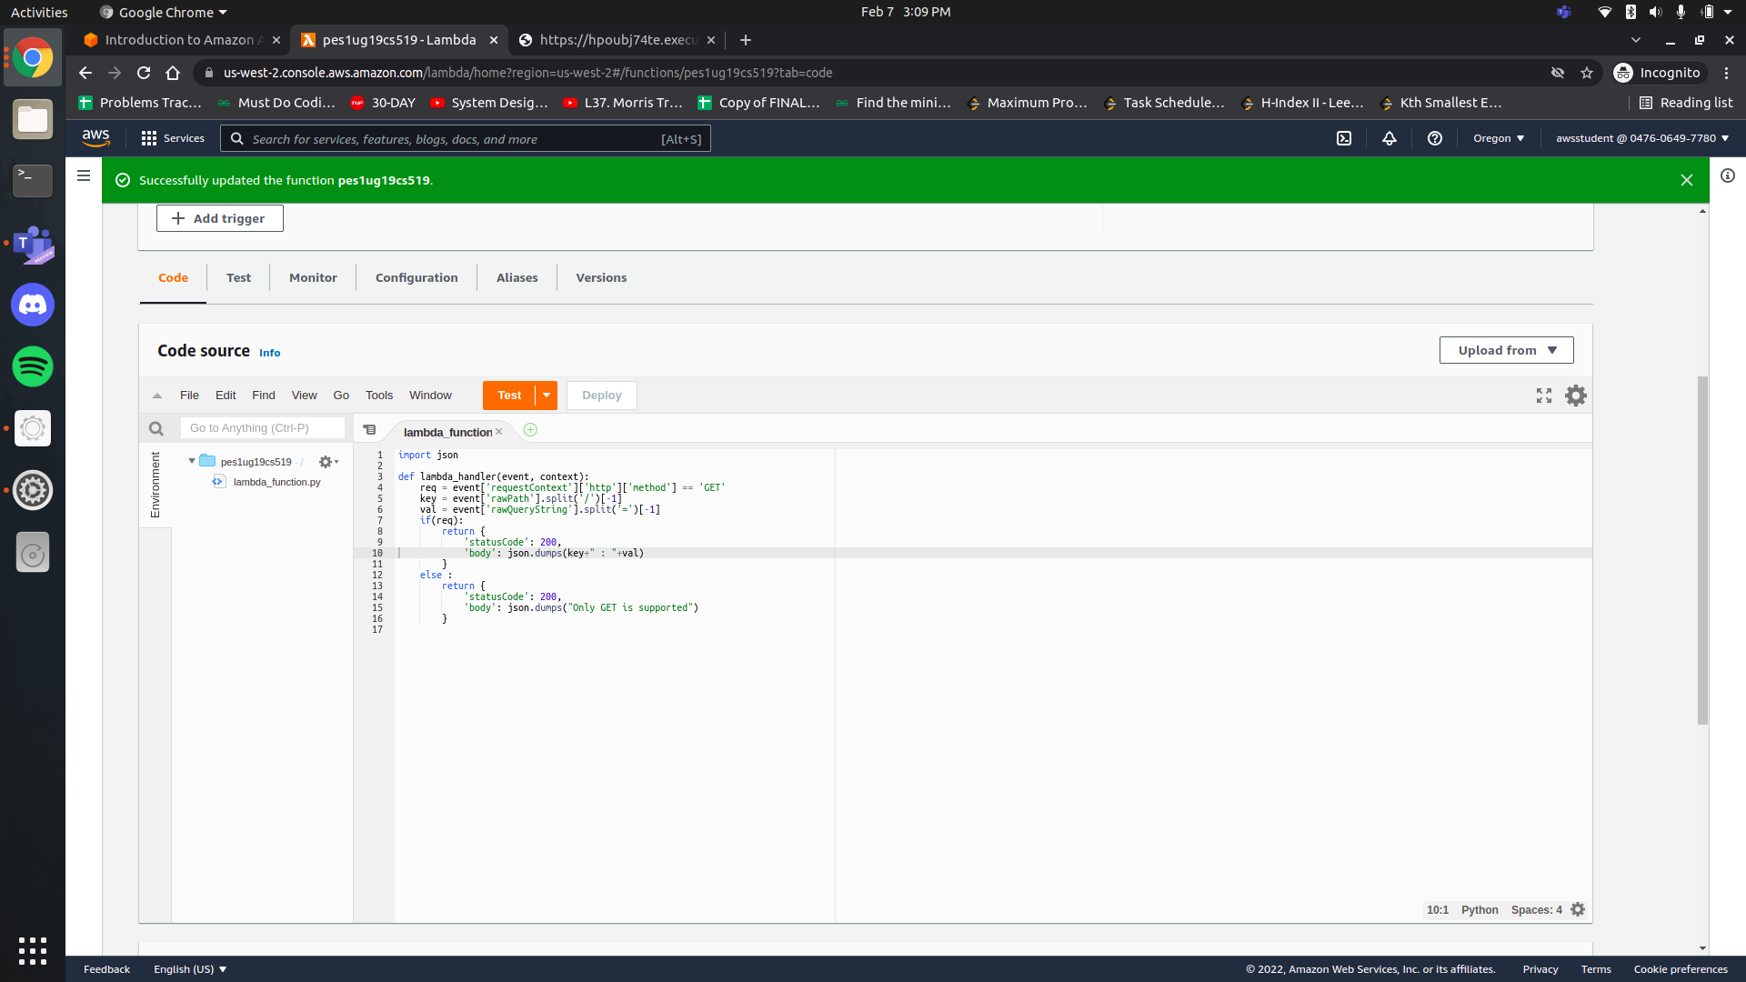

1. d. Successful submission on the submission dashboard

